Module Assembly - TopCoder NodeJS Member Search API
Deployment Guide

Revision History
Author | Revision Number | Date
hesibo | 1.0 | 2014/03/17

Deployment Instructions 3
1. Organization of Submission 3
2. Database setup 3
3. Configurations 3
4. Deployment Instructions 4
5. Verification by tests 4
5.1. Js lint 4
5.2. Mocha 5
6. Verification by pages 6
7. Resource Contact List 11

Deployment Instructions

Organization of Submission
The folder structure (the root directory of the submission is referred as the <base> throughout the document.
Name | Description
tc-api/ | Main application source code of this assembly.  Contains only new or changed files.
tc-api/docs/Module Assembly - TopCoder NodeJS Member Search API.doc | This file.

Database setup
NOTE: Step 7 and 8 are not necessary if you first run mocha test on localhost (see section 5.2) and later test on heroku(see section 6).

- Upload the submission to /mnt/shared/temp_files/
- Login vm as ‘tc’ account
- cd /mnt/shared/temp_files
- unzip submission.zip
- su informix -l
- cd /mnt/shared/temp_files/submission/tc-api/db_scripts
- dbaccess - member_search_delete.sql
- dbaccess - member_search_create.sql

Configurations
There are two BASH scripts used to ease the deployments and launching of the application.
The configurations are defined in these scripts to export the environment variables.
One of them is for heroku development “tc-api/deploy/heroku.sh”, where the configurations are defined.
Please add heroku config:set TC_VM_IP=$TC_VM_IP
echo "INFO: Set environment variables"

heroku labs:enable user-env-compile

## Export the parameters
heroku config:set JAVA_HOME="/usr/lib/jvm/java-1.6.0-openjdk"
heroku config:set TC_VM_IP=$TC_VM_IP

No changes are required to tc-api/deploy/development.sh.

Deployment Instructions
- Setup heroku and database.
- Run git clone git://github.com/cloudspokes/tc-api.git tc-api
- Run cd tc-api
- Run git checkout fdb737956637ca31fbf00013f020045183dcf7d0
- Copy all files from <base>/tc-api to checked out tc-api and override all files
- Run npm install
- Modify configuration following section 4.
- In checked out tc-api run:
  - git add .
  - git commit –m “commit message”
  - chmod +x deploy/heroku.sh
  - export TC_VM_IP = <your-vm-address>
  - . deploy/heroku.sh all
  - After running the script, you can use “git remote -v” to see the “heroku” remote repo. The remote repo will be like git@heroku.com:<app-name>.git, you can know the create app name here.
- To deploy application in local environment run:
  - chmod +x deploy/development.sh
  - export TC_VM_IP = <your-vm-address>
  - . deploy/development.sh
  - node ./node_modules/.bin/actionHero start or npm start
  - Server is listening on port 8080.
  - If you get error Could not load default informix_bindings. Error: libthsql.so: cannot open shared object file: No such file or directory. Run again “. deploy/development.sh”

Verification by tests

Js lint
Install the node-jslint in your local environment globally by “sudo npm install jslint -g".
Check the following files (which contain the application code) under the <base>/tc-api
jslint -nomen actions/memberSearch.js
jslint -nomen routes.js
jslint -nomen test/test.memberSearch.js

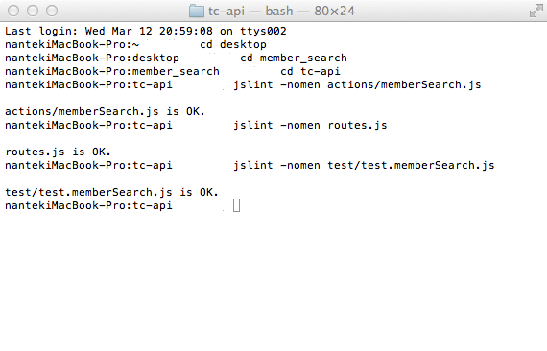

Mocha
Deploy application to localhost. See 4.8.
If you want to run test in another bash terminal, please run command 4.9.b and 4.9.c first.
Run the “node_modules/.bin/mocha test/test.memberSearch.js” from within the “<base>/tc-api/” directory
To run mocha test in heroku add this part “API_ENDPOINT=<app-name>.herokuapp.com”
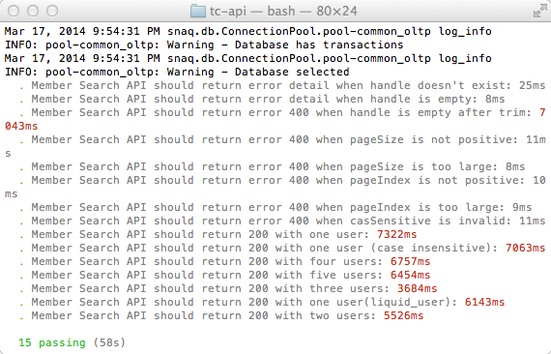

Verification by pages
To test application in heroku replace in below URLs localhost:8080 by <app-name>.herokuapp.com
You must generate data before testing. (refer section 2)

Verify application deployed in localhost

http://localhost:8080/api/v2/users/search?handle=bc&caseSensitive=false
One user return.
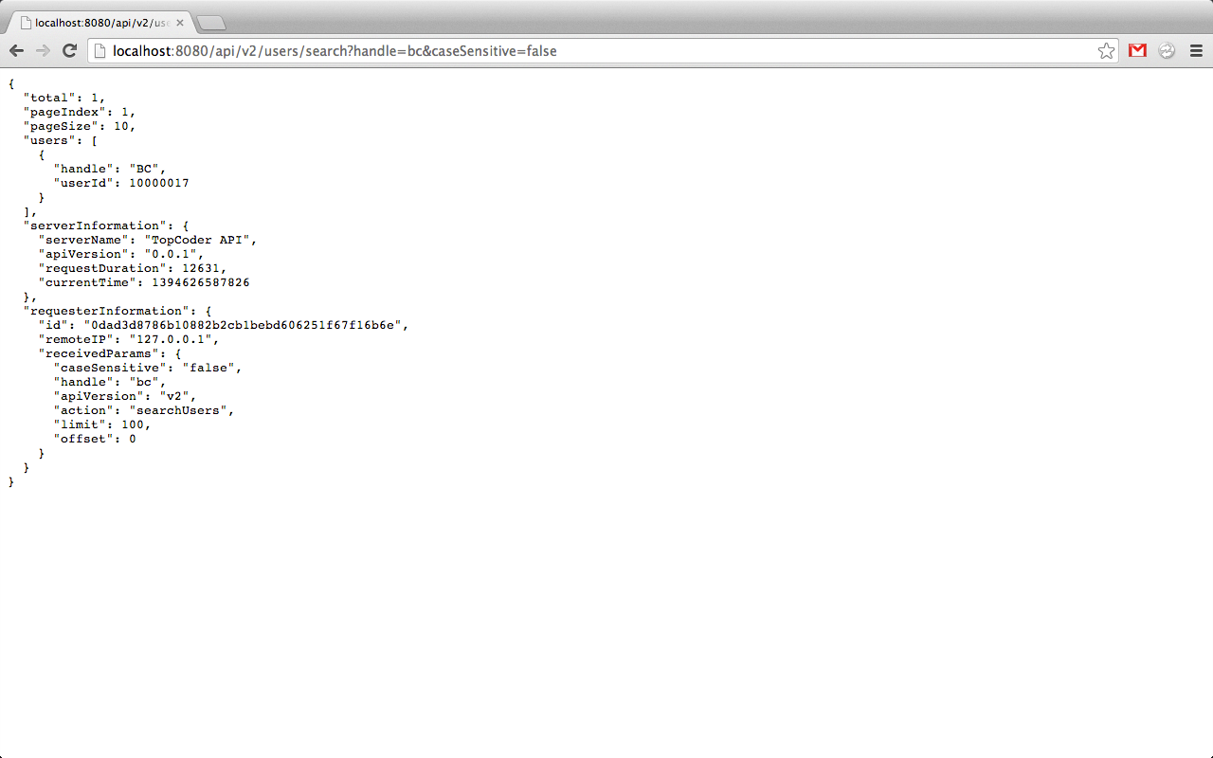

http://localhost:8080/api/v2/users/search?handle=&pageSize=5
handle is empty, return error detail
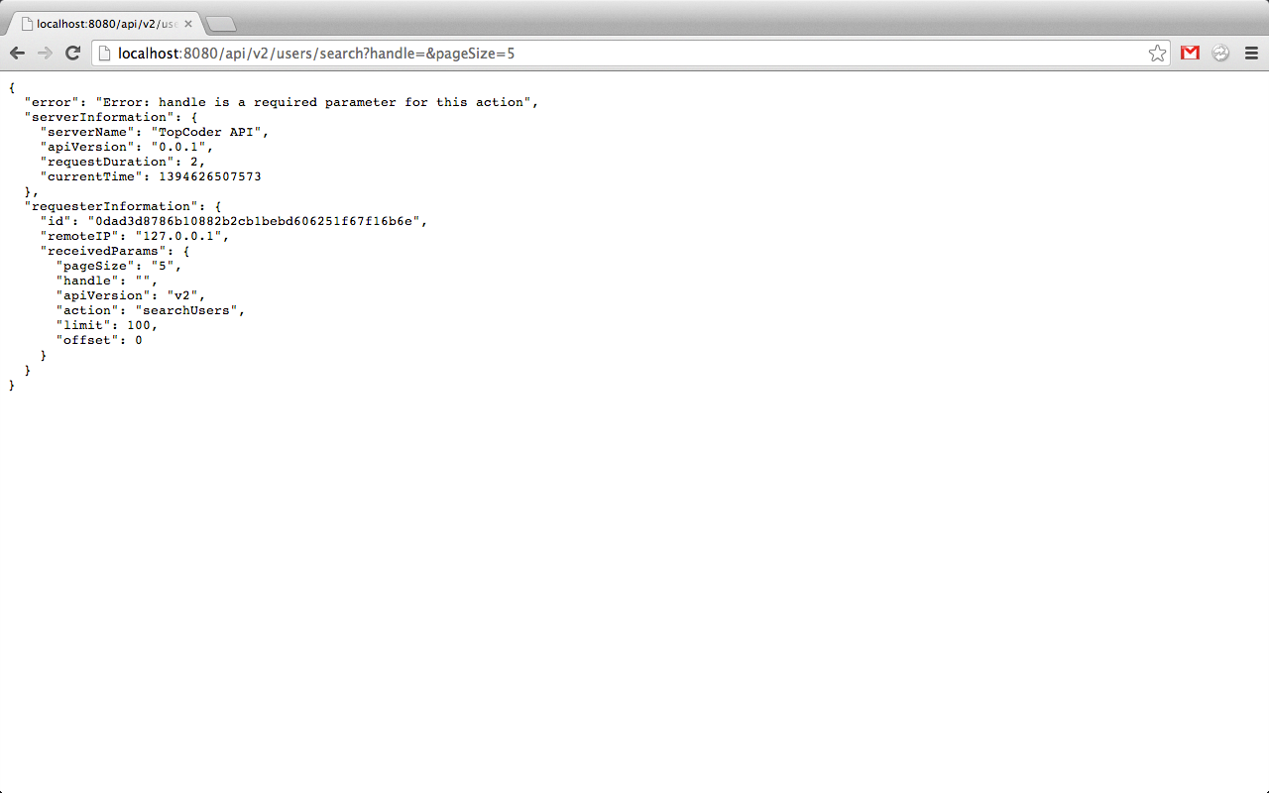

http://localhost:8080/api/v2/users/search?handle=a%&pageSize=6&pageIndex=3
Three users return.
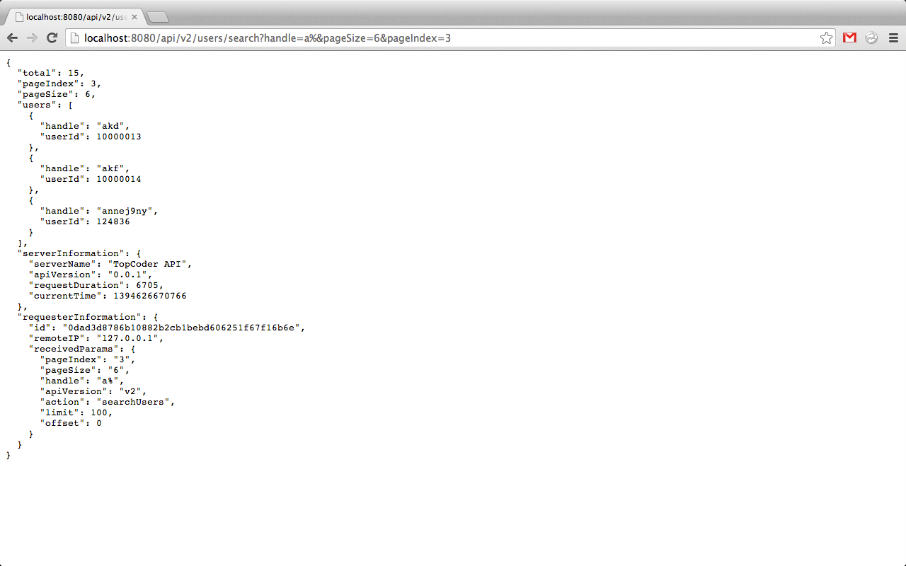

Verify application deployed in Heroku

http://<app-name>.herokuapp.com/api/v2/users/search
handle parameter is missed, return error detail
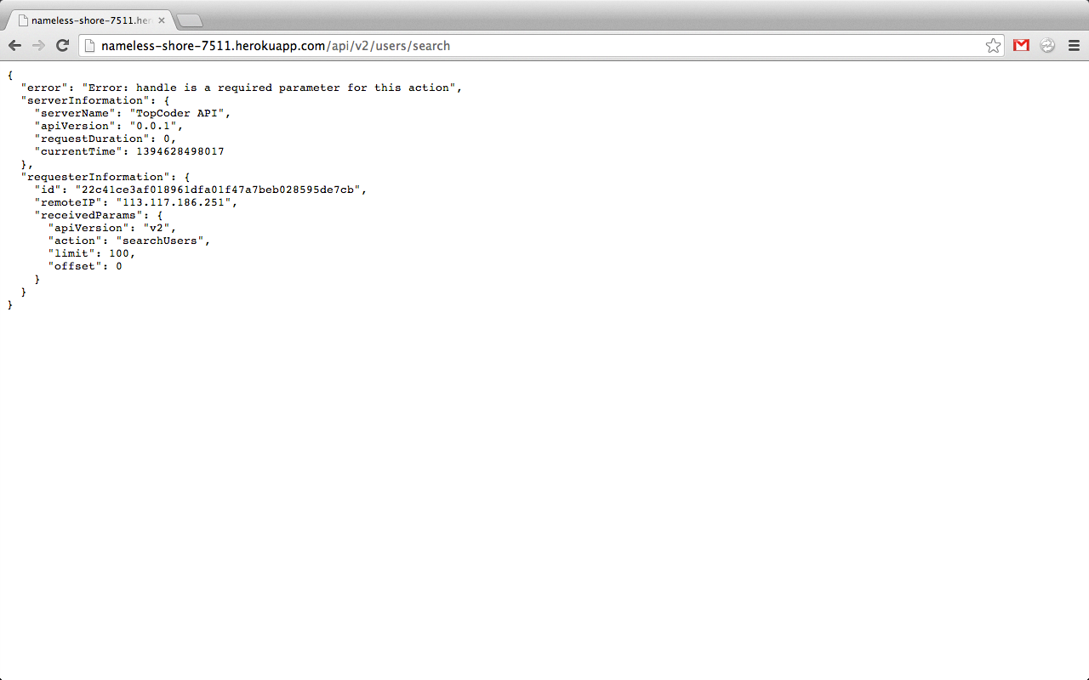
http://<app-name>.herokuapp.com/api/v2/users/search?handle=a%&pageSize=10000&pageIndex=3
pageSize is too large, expect 400.
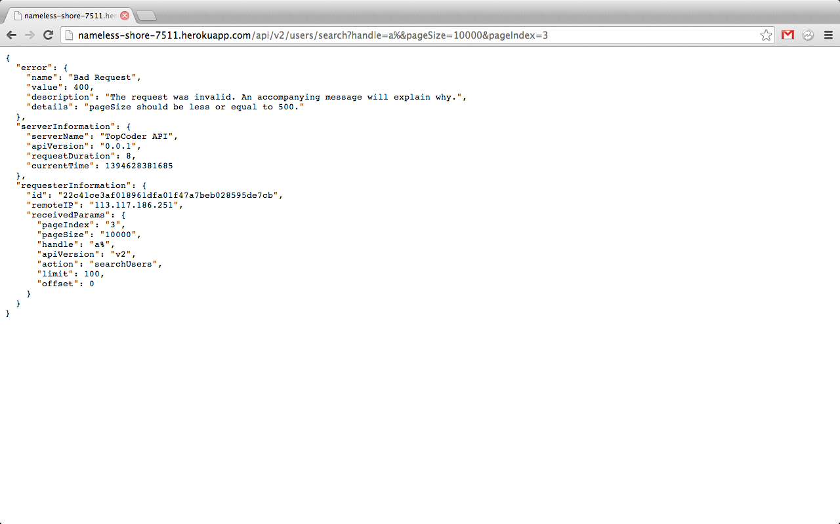

http://<app-name>.herokuapp.com/api/v2/users/search?handle=b%&pageSize=4&pageIndex=2&caseSensitive=false
Two users return.
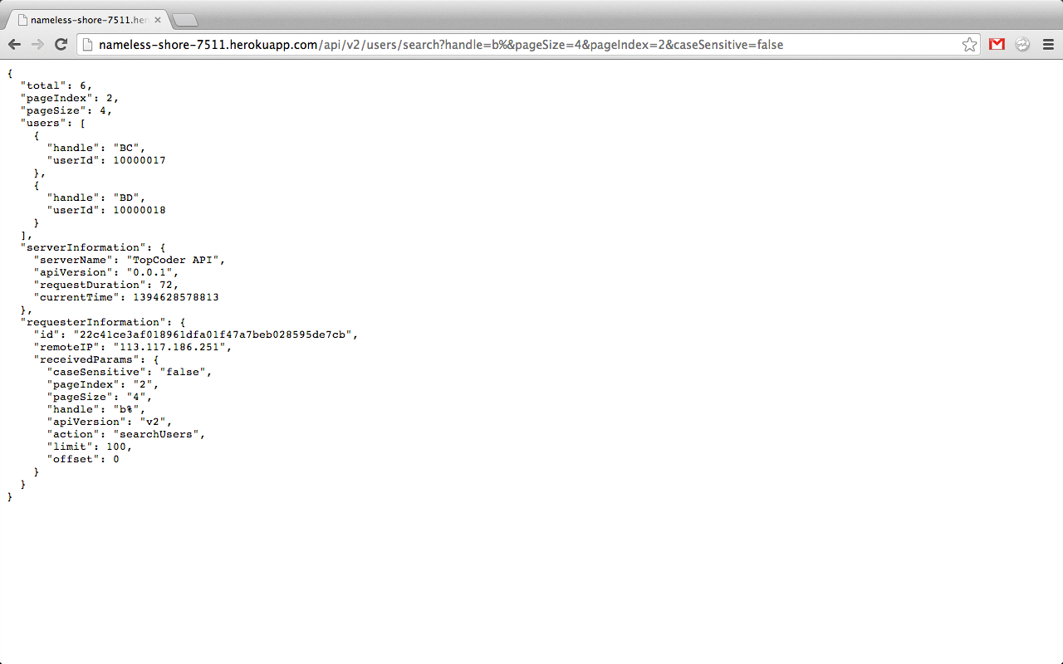

http://<app-name>.herokuapp.com/api/v2/users/search?handle=h_f_%
One user return
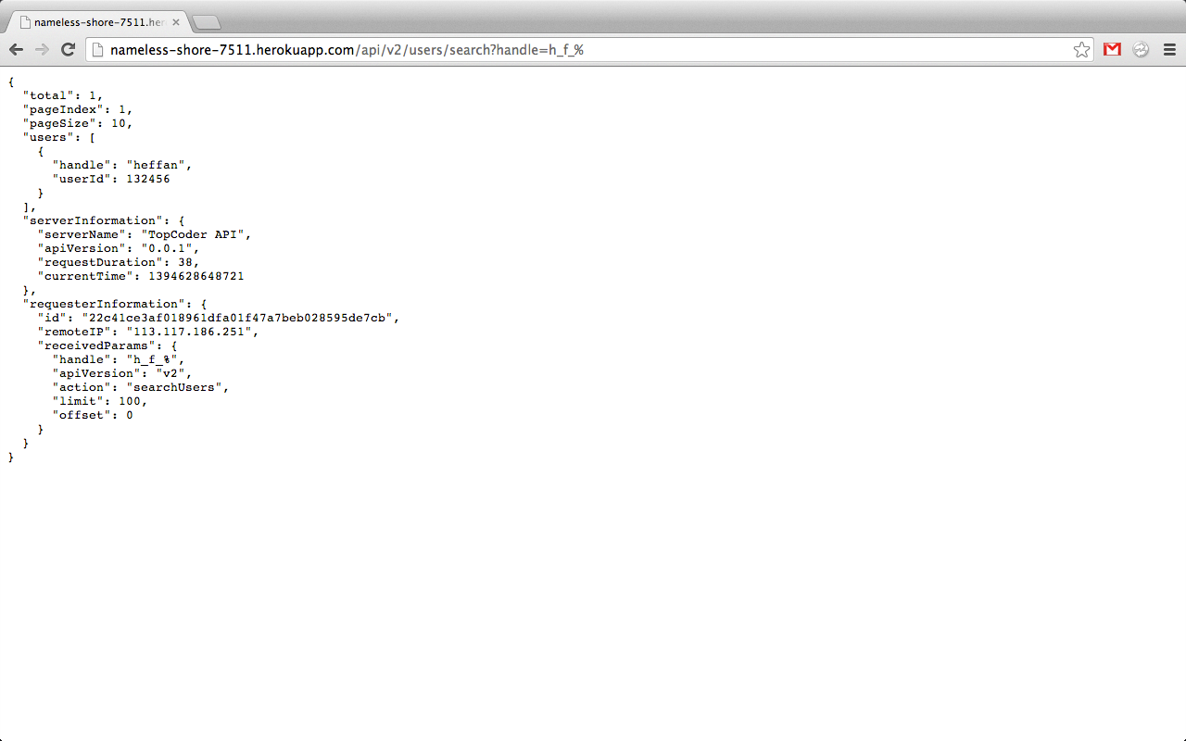

Resource Contact List
Name | Resource Email

